# Thank you for using Documents

### Thank you for using Documents. A variety of features have been added to the new Documents app, making it easier and more convenient to use. The Documents app is your smart document assistant, allowing you to easily find, view, write, share, and manage documents.

### Open documents in various formats

Documents in most mainstream formats can be previewed.

**How to use:**

* View your documents with the Documents app.
* Use "Open with" in a third-party app and select the Documents app.

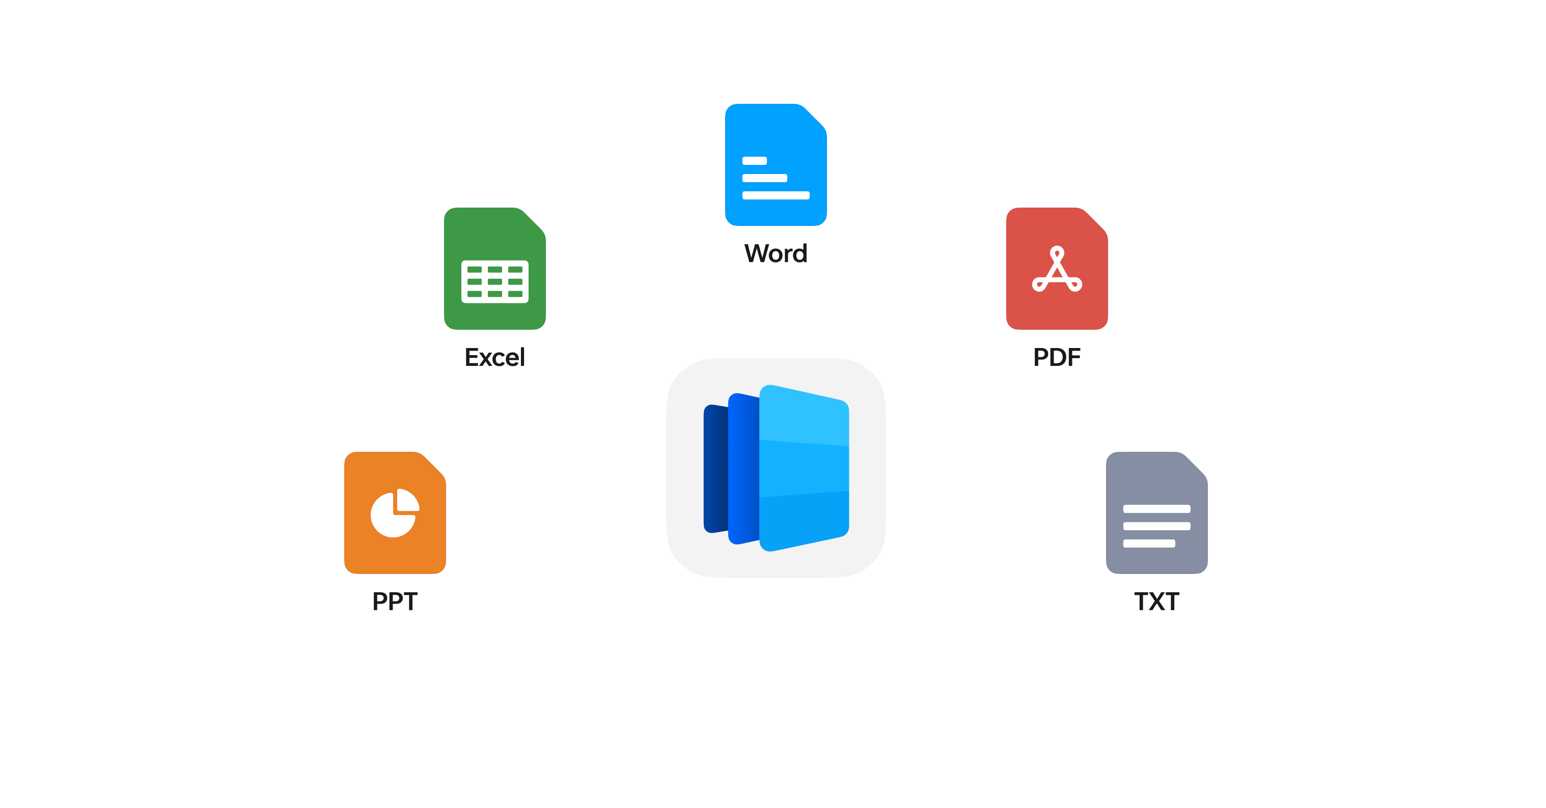

## Thank you for using Documents

Document search is more intelligent and convenient, making it easy to find documents by title and content

**How to use:**

* Open the Documents app and enter keywords in the top search box to conduct searches.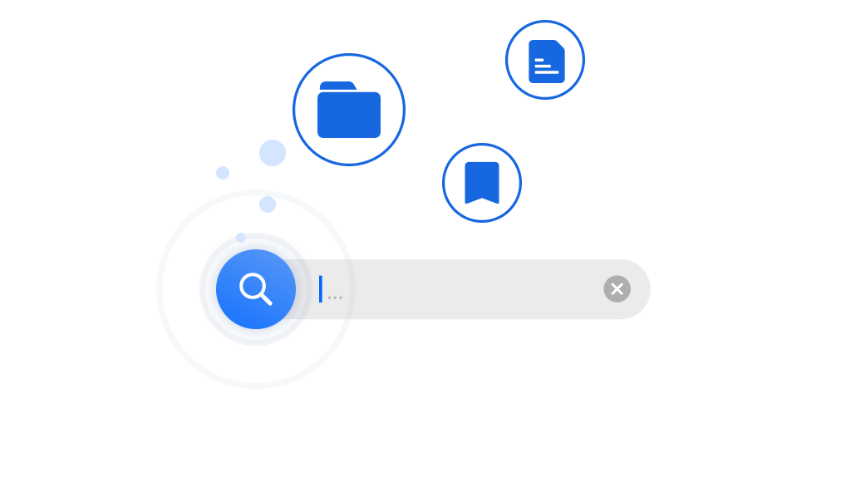

## Open the Documents app and enter keywords in the top search box to conduct searches.

The Document Summary feature extracts key content from documents to help you understand lengthy content faster. Available on some device models only.

**How to use:**

* Open a document and choose "AI Assistant for Notes - Summarize".
* Open the Documents app and choose "All tools - Summarize".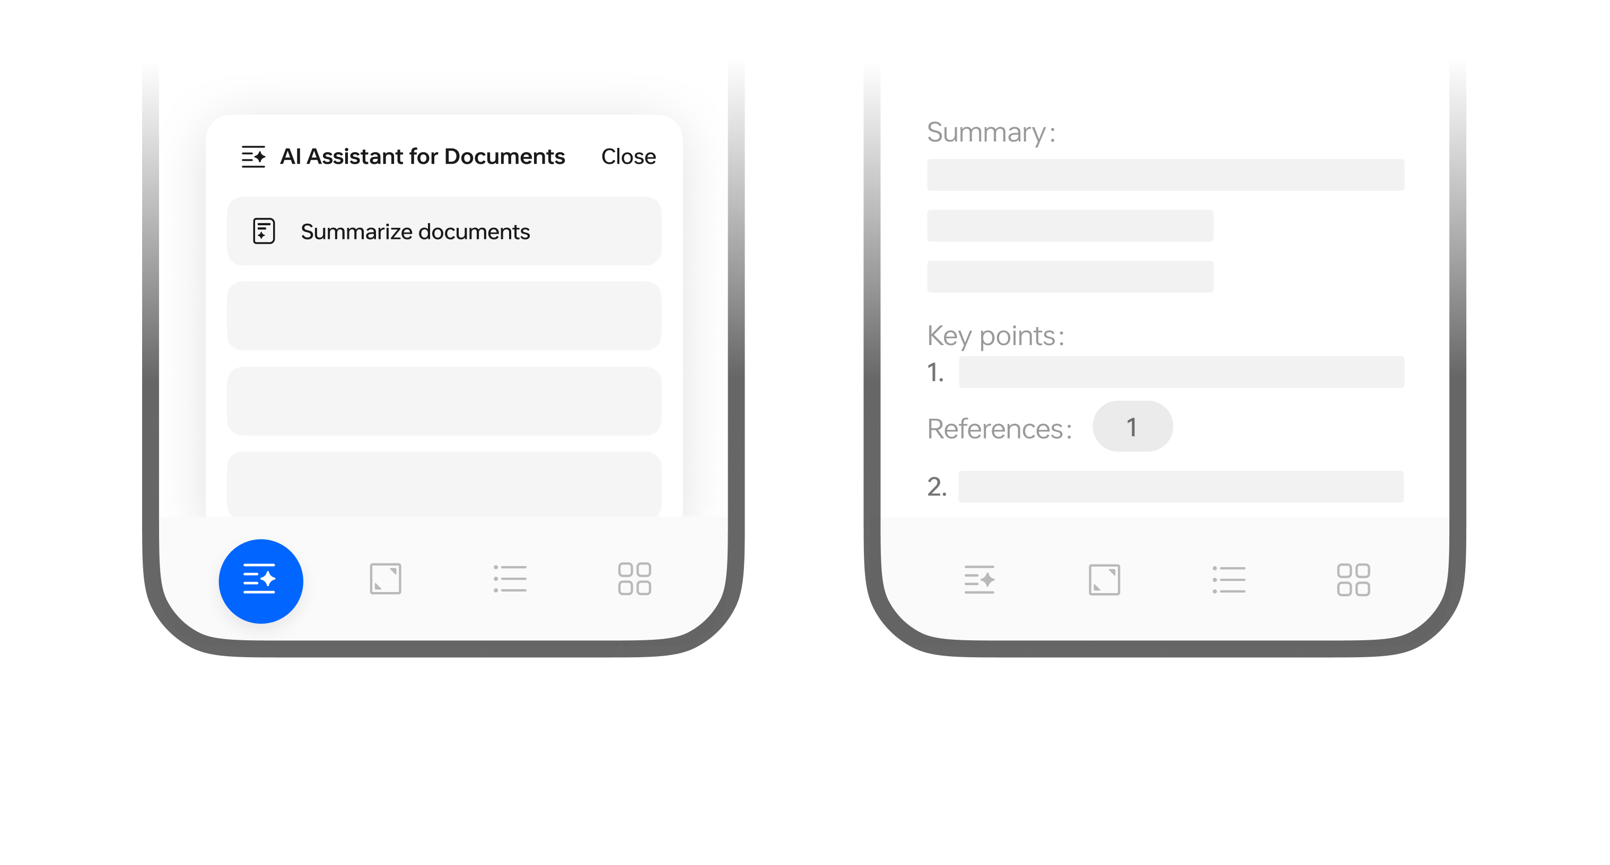

## View translations along with the original content

You can translate entire documents and show translations alongside the original text. Available on some device models only.

**How to use:**

* Open a document and choose "AI Assistant for Notes - Translate".
* Open the Documents app and choose "All tools - Translate".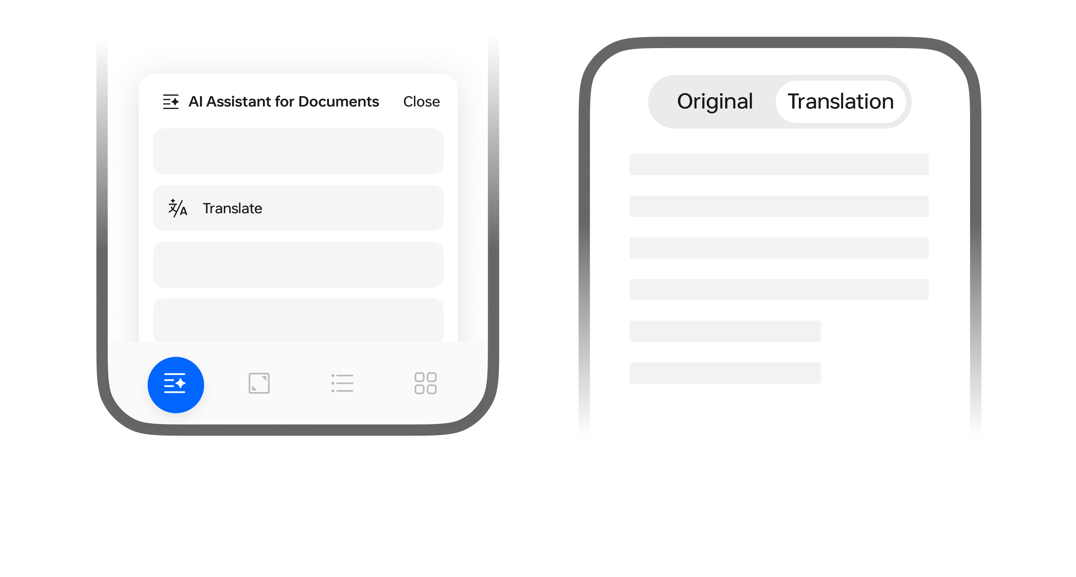

## Try out AI Rewriter to improve your writing

You can use AI Rewriter capabilities to make content creation easier. AI Rewriter functions include Polish, Continue writing, Elaborate, Shorten, Casual, and Formal. Available on some device models only.

**How to use:**

* Open a document and select AI Assistant for Notes, then select an AI Rewriter function as needed.
* Open a document, select a block of text, then select an AI Rewriter function as needed.